 

Q1:

Software Requirements Specification

for

<Project>[Student must replace this line by the name of project in the exam paper] (0.25 point)

**Version 1.0 approved**

**Prepared by**

**<author>[Student must replace <author> by your full name and studentID] (0.25 point)**

**<organization>[Student must replace this line by the name of the FU Campus you take the exam] (0.25 point)**

**<date created> [Student must replace this line by the date you take the exam] (0.25 point)**

Q2:

<Student must replace this line, answer Q2 by drawing 1 context diagram that reflect this exam paper and copy and then paste the image of that context diagram here

Notes:

1. Draw the correct syntax to describe the context diagram (0.3 point)
2. List the name of >= 4 external entities (0.6 point)
3. Draw the data flows described in this exam paper (1.6 points)

>

1,

External Entities:

External entity: 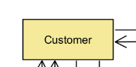

System:

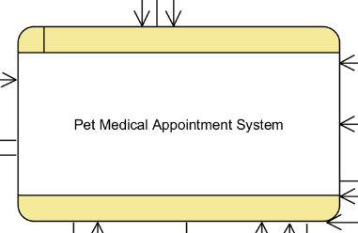

Data store:

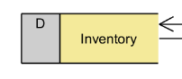

2. Customer, Veterinarian, Clinic Staff, Clinic Manager

3.

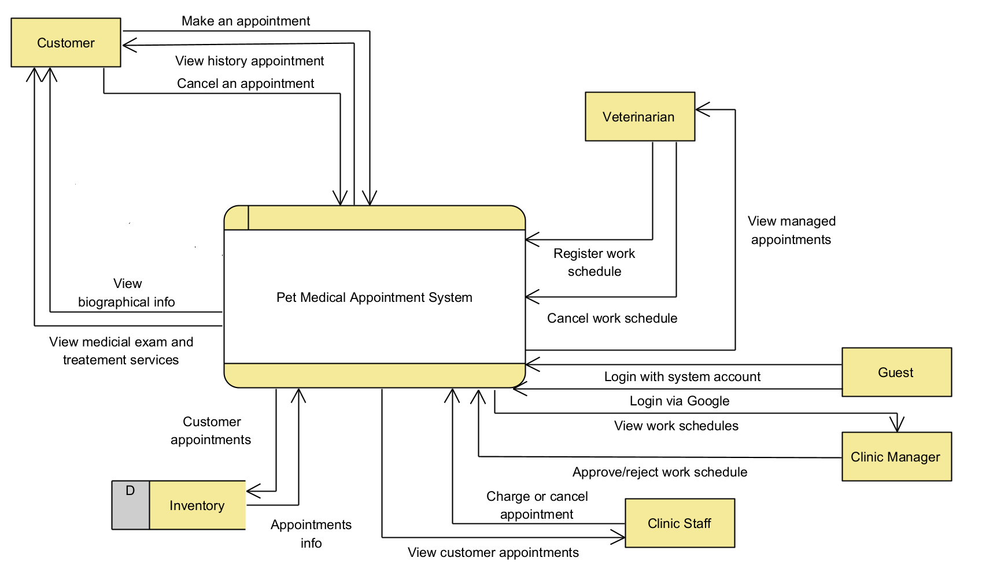

Q3:

< Student must replace this line

Notes:

1. Draw the correct syntax to describe the use case diagram (0.4 point)

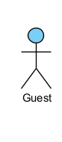Actor

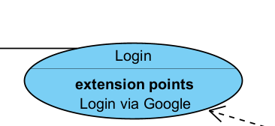  
Usecase

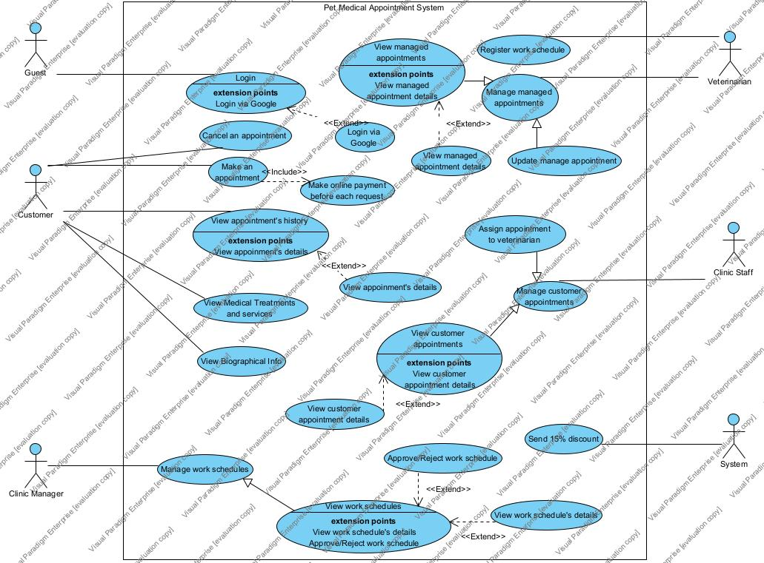

>

<Student must replace this line, answer Q3 by drawing 1 use case diagram that reflect this exam paper and copy and then paste the image of that use case diagram here>

< Student must replace this line, **briefly describe** the actors of the diagram by fill the content to below table>

| **#** | **Actor** | **Description** |
| --- | --- | --- |
| 01 | Guest | Individuals who do not have access to the system, typically representing potential customers or visitors who are not yet registered or logged in. |
| 02 | Customer | People who seek veterinary services for their pets. |
| 03 | Veterinarian | Professionals responsible for providing medical care to animals. |
| 04 | Clinic Staff | Personnel working within the clinic, such as receptionists, nurses, or assistants. |

< Student must replace this line, **briefly describe** the use cases of the diagram by fill the content to below table>

| **#** | **Use Case** | **Actors** | **Description** |
| --- | --- | --- | --- |
| UC-01 | Create an appointment | Customer | Create an appointment for meeting an veteriniaran |
| UC-02 | Register work schedule | Veterinarian | Register an work schedule that allow clinic staff to manage appointment for them |
| UC-03 |  |  |  |

Q4:

< Student must replace this line, answer of Q4 by fill the content to below table that reflect this exam paper

Notes:

1. Describe >= 5 business rules (1.5 point)
2. For each incorrect business rule, 0.3 points will be deducted

>

| **ID** | **Rule Definition** | **Use cases** |
| --- | --- | --- |
| BR-01 | Appointment date cannot be in the past. | UC-01, UC-02 |
| BR-02 | Title is required. | UC-01 |
| BR-03 | Cannot register 2 work schedule at the same time | UC-02 |
| BR-04 | Description is required | UC-01 |
| BR-05 | One or more pets must be included in each appointment | UC-01 |

**Q5:**

< Student must replace this line, the answer of Q5 must have detail and specific in number of 2 non-functional requirements for the system>